GAMR3531 Report Template
Repo URL: | https://github.com/GAMR3531/cw26-beani3/tree/GPU-Side-Optimisation |  |  |  | Commit: | 3c31ec53286019f8e2dc29edd05b40ae2681c14b
Tick all parts of the submission that this report covers:
GPU | Profile run and documented but no changes made. | All redundant binding of GPU buffers and shaders removed. Profile run and documented for this change. | Successfully Implement either a depth-pre pass or move to deferred or tiled rendering. Profile run and documented. | Successfully Implemented a LOD scheme. Profile run and documented. | Successfully Implemented instanced rendering. Profile run and documented. | Rewrite the Bloom effect in compute shaders or GPU side frustum culling in a compute shader.  Profile run and documented. | Innovation beyond the specification.
 | ☐ | ☐ | ☐ | ☐ | ☐ | ☐ | ☐
CPU | Profile run and documented but no changes made. | Replace polymorphic games object with composable game objects.  Profile run and documented. | Minimised memory footprint of all classes.  Improve memory use of UBO/UBOManager. Profile run and documented. | Successfully implemented SIMD collision checks (beyond default/GLM optimisation) or CPU side frustum culling.  Profile run and documented. | Successfully Implemented a spatial partitioning scheme for broad phase collision checks. Profile run and documented. | Manually manage all RAM allocations with a sensible scheme.  Profile run and documented. | Innovation beyond the specification.
 | ☐ | ☐ | ☐ | ☐ | ☐ | ☐ | ☐
What change(s) have you made: |  | Removed redundant binds for FBOs, material, geometry, etc…
Which tools have you used to provide evidence for the change(s) you have made? |  | ☐ | Tracy
 |  | ☐ | RenderDoc/NSight
 |  | ☐ | Custom instrumentation
 |  | ☐ | Other (please state)
Put your Evidence here: |  | 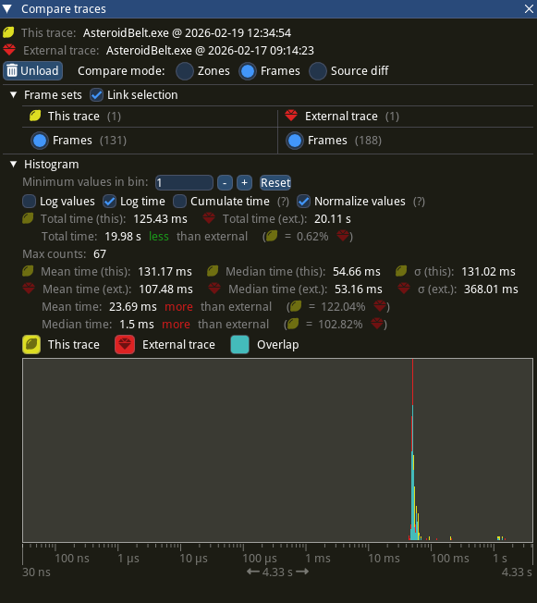  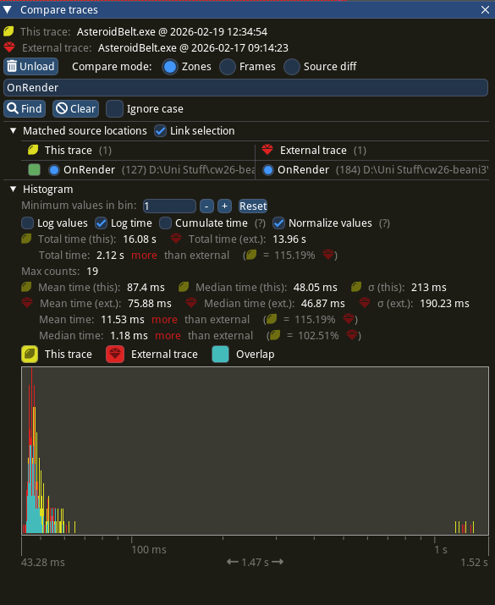  Figure 1: On Render() Comparison  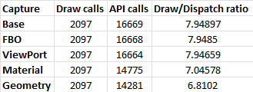  Figure 3: Per Stage Implementation Table  Figure 2: Overall Comparison
Anything else you want to add? |  | Though the API calls had reduced significantly, the gain in performance was less than expected

